**Report**

Shotan Syrym

ITSE-1907

Car rental

At my third job, I made six pages of my website.

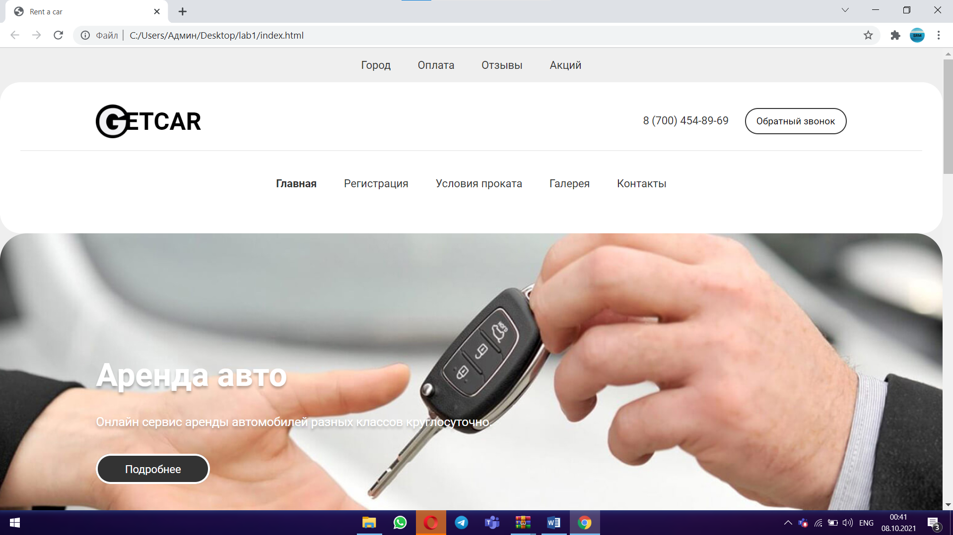

These are the main page, registration page, registered page, contact page,

condition page, and gallery page.

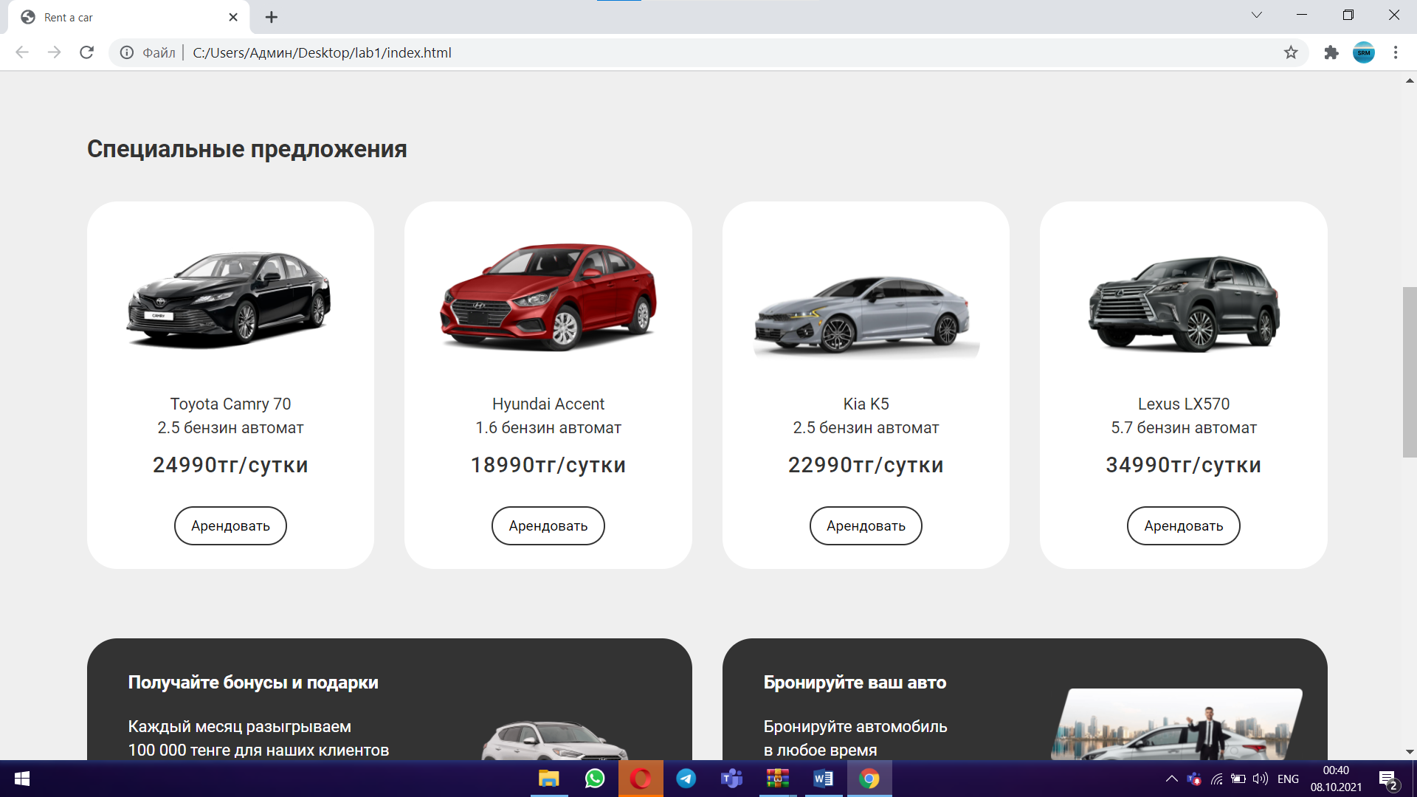

Now I have changed the main page. Changed the name of the buttons. After that, I added a slider to the main page. Since I had many extra tabs, I made them smaller.

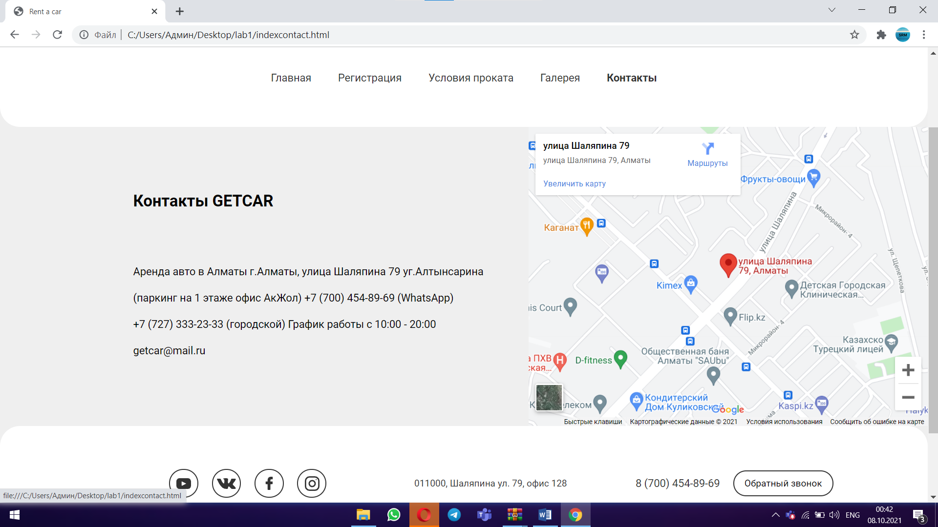

Then I made a contact page and a Google map. After that, I made another page where there is a registration form.(Login ,Sign up )

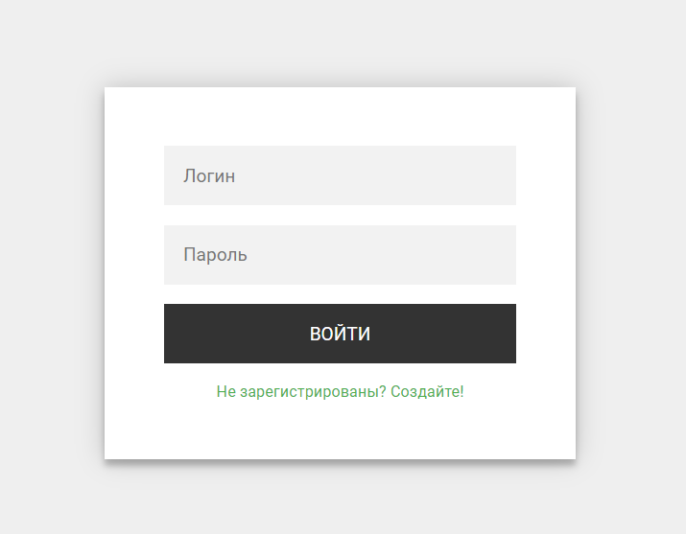 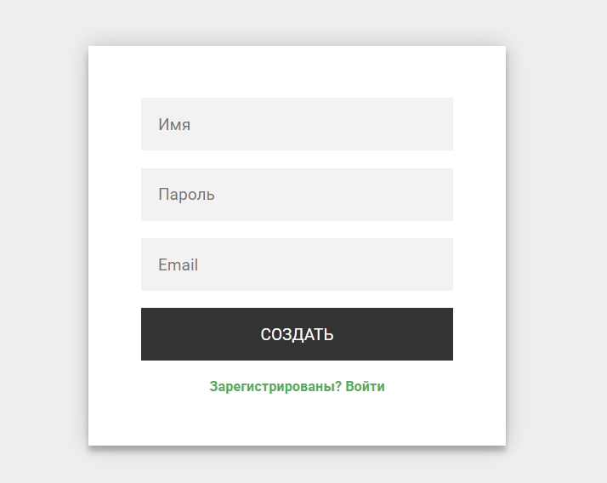

Also worth mentioning, I made buttons with animation. Using CSS

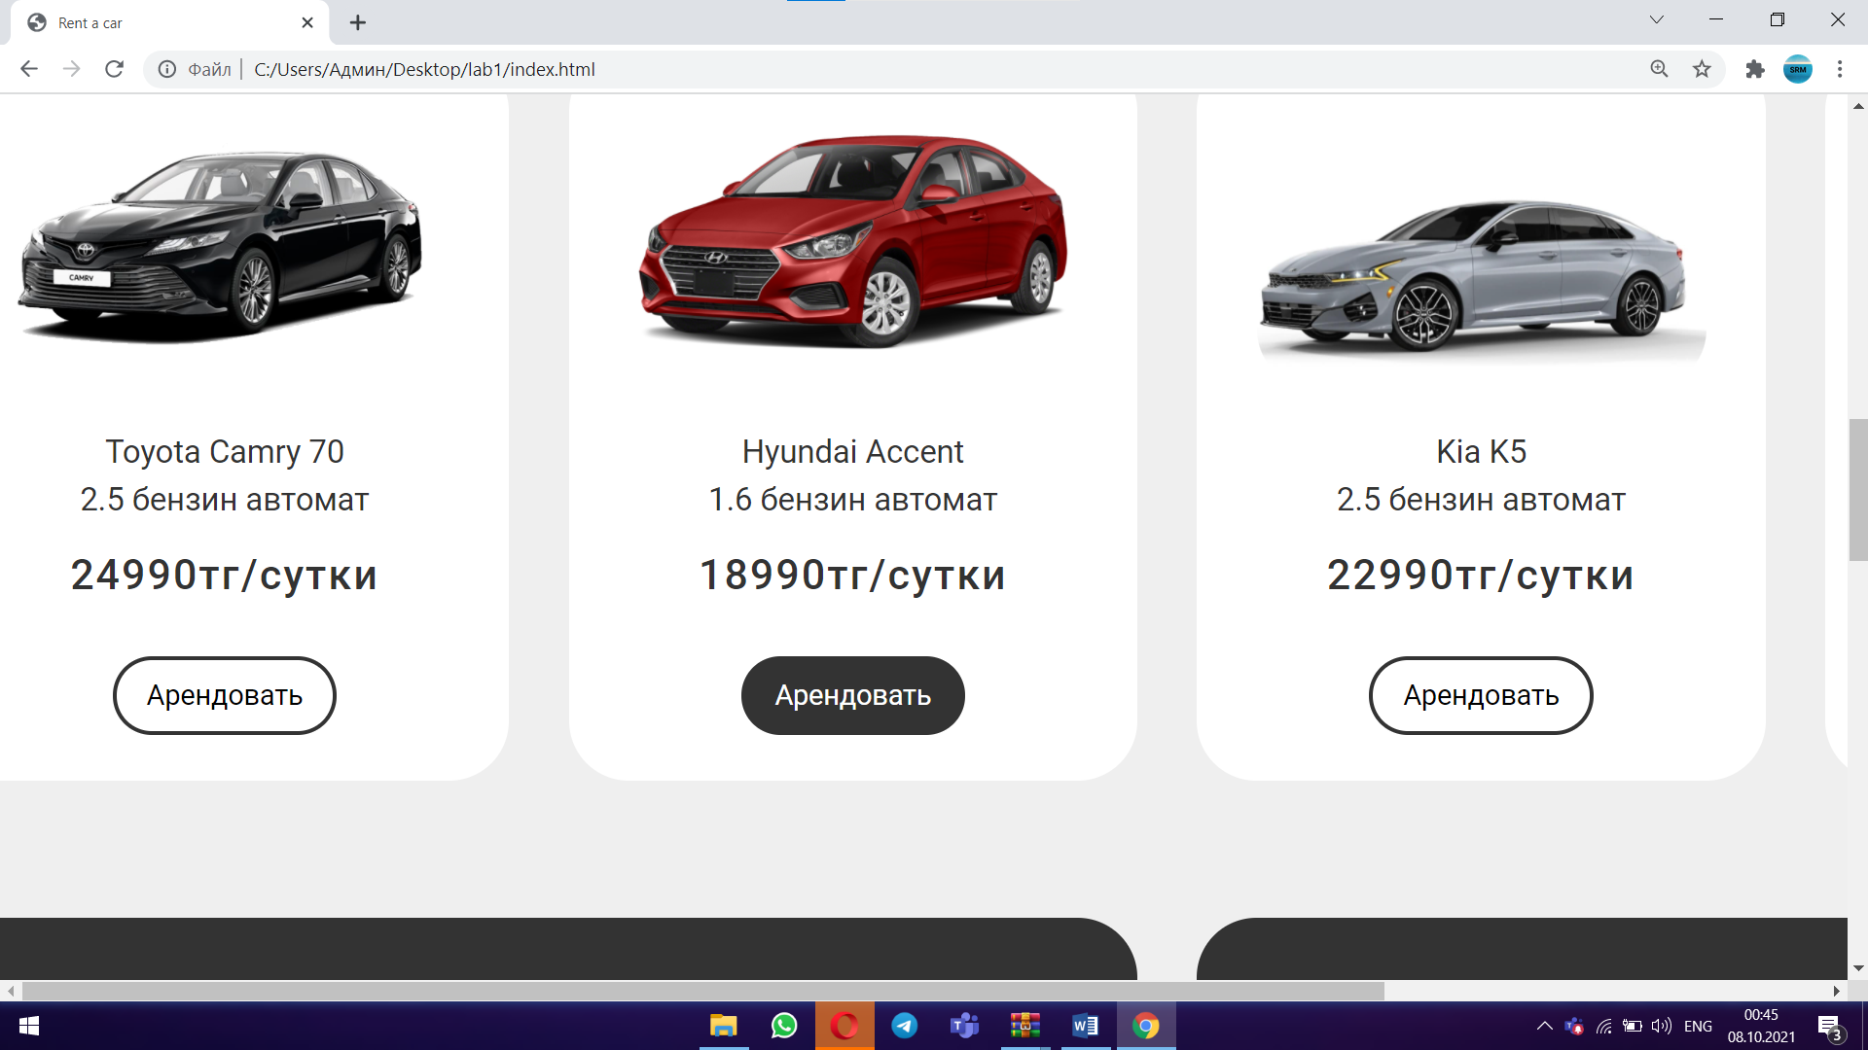

Then I made a gallery page. There is a carousel of photos of cars.

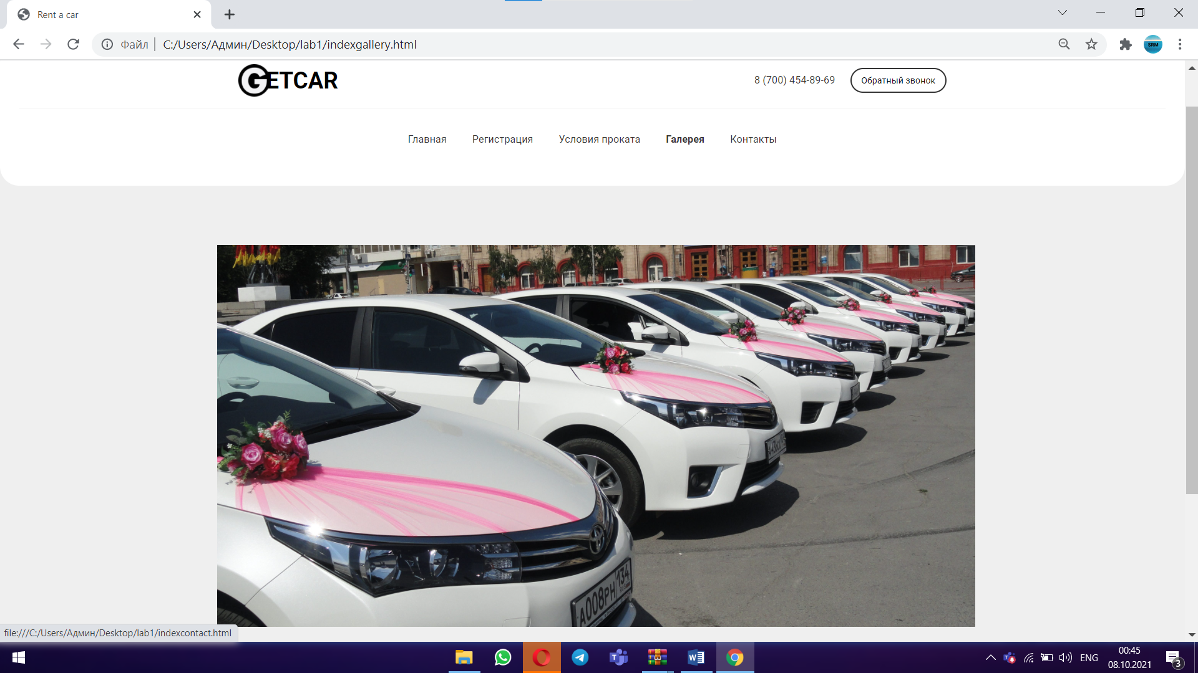

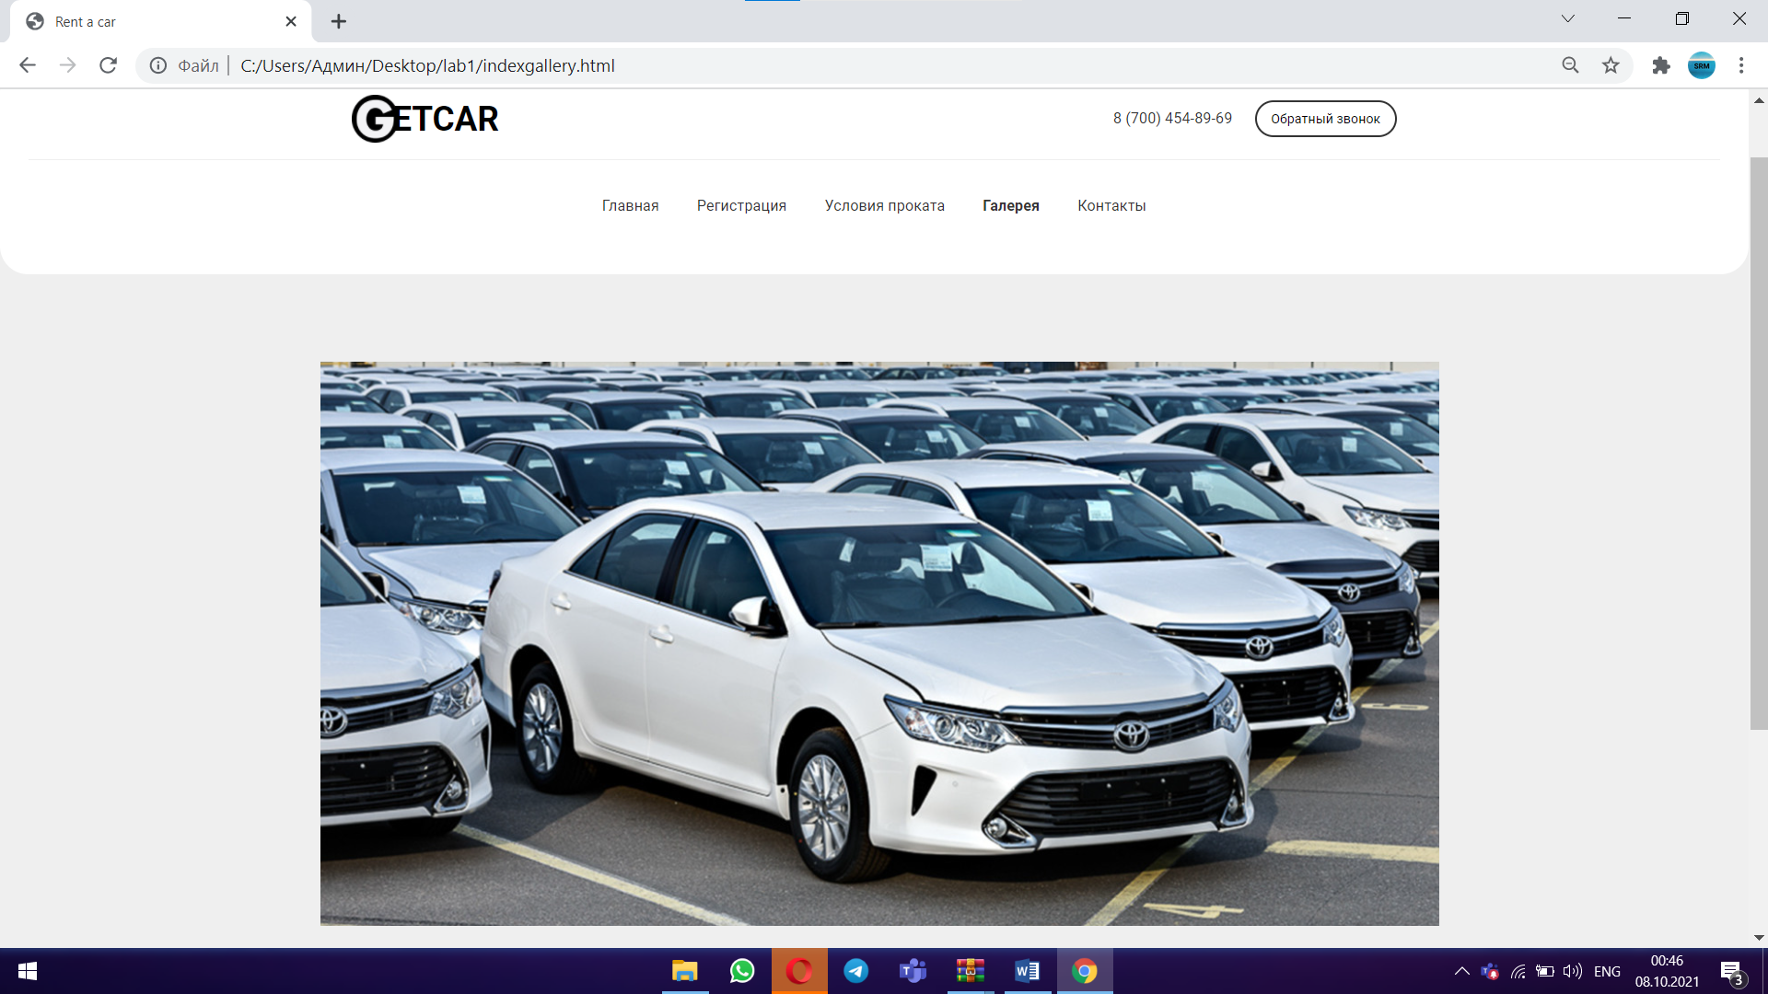

Next, we have a page where there are basic rental rules.

